Lab - Build a Custom Form Validator

**Objective:**

The objective of this lab exercise is to learn how to build a custom form validator in Angular. By completing this exercise, you will gain hands-on experience in creating a custom validator function and integrating it into an Angular form. You will understand how to define and use custom form validators to enforce specific validation rules for form inputs. Additionally, this exercise will help you become familiar with Angular's reactive forms and the usage of form controls and form groups. By the end of this lab, you will have a solid understanding of how to extend Angular's built-in form validation capabilities with custom validators to create robust and tailored form validation in your Angular applications.

**Step 1: Set up a new Angular project**

1. Open your terminal or command prompt.
2. Create a new Angular project by running the following command:



1. Change into the project directory:



**Step 2: Create a custom form validator**

1. Generate a new component named custom-validator by executing the following command:



1. Open the custom-validator.component.ts file located in the src/app/custom-validator directory.
2. Import the ValidatorFn and AbstractControl from @angular/forms by adding the following import statements at the top of the file:



1. Implement a custom validator function. For example, let's create a validator that checks if a value is a multiple of 5:

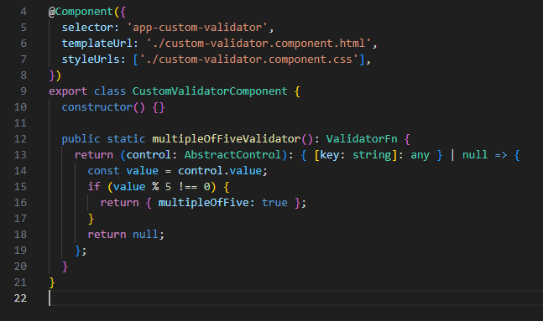

This function returns a ValidatorFn that takes an AbstractControl as a parameter. It checks if the control's value is a multiple of 5 and returns an error object if it's not.

1. Save the file.

**Step 3: Use the custom form validator**

1. Open the app.component.html file located in the src/app directory.
2. Replace the existing content with the following code:

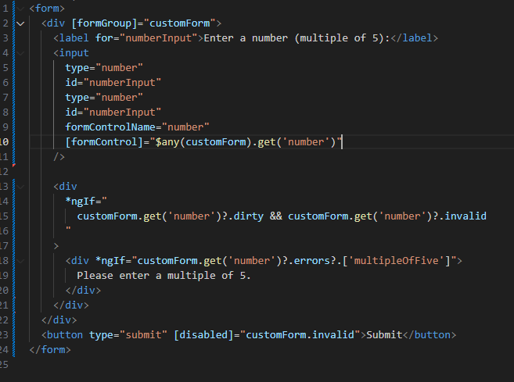

This code sets up a simple form with an input field for the number and displays an error message if the number is not a multiple of 5.

1. Open the app.component.ts file located in the src/app directory.
2. Import the FormGroup, FormControl, and the custom validator by adding the following import statements at the top of the file:



1. Update the AppComponent class to include a customForm instance of FormGroup with a number control that uses the custom validator:

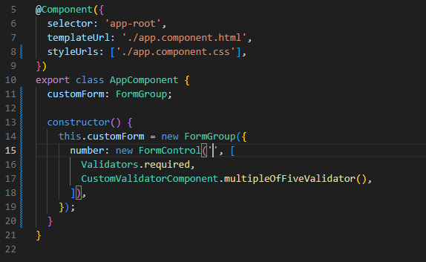

1. Save the file.

**Step 4: Update app.module.ts**

To use the custom form validator, we need to update the app.module.ts file to include the necessary form module and register the custom validator.

1. Open the app.module.ts file located in the src/app directory.
2. Import the FormsModule , ReactiveFormsModule from @angular/forms and custom validator by adding the following import statements at the top of the file:



1. In the imports array of the @NgModule decorator, add FormsModule and ReactiveFormsModule as imports:

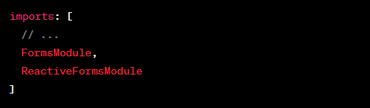

1. Add the custom validator to the declarations array.



1. Save the file.

With these updates, the custom form validator can be used in your Angular application.

**Step 5: Test the custom form validator**

1. Open a terminal or command prompt.
2. Run the Angular development server by executing the following command:



1. Open a web browser and navigate to [http://localhost:4200](http://localhost:4200%20) to see the form.
2. Enter a number that is not a multiple of 5 (e.g., 7) in the input field and try to submit the form. You should see an error message displayed.
3. Enter a number that is a multiple of 5 (e.g., 10) in the input field, and the form should submit successfully without any error messages.

Congratulations! You have successfully built and tested a custom form validator in Angular.

I hope this step-by-step lab exercise helps you understand how to create and use custom form validators in Angular.

*******************************************************************************************************************************